ADVANCED WEB TECHNOLOGY

ASSIGNMENT -4

1831017

S.HARIHARAN

|  |
| --- |
| **INDEX** |

|  |  |
| --- | --- |
| **S NO** | **TITLE** |
| 1 | ANGULAR-1 |
| 2 | ANGULAR-2 |
| 3 | ANGULAR-3 |
| 4 | ANGULAR-4 |
| 5 | ANGULAR-5 |

**EX NO :1 ANGULAR-1**

**10/09/20**

<!DOCTYPE html>

<html ng-app>

<head>

<title>My AngularJS App</title>

<script src="https://ajax.googleapis.com/ajax/libs/angularjs/1.6.9/angular.min.js"></script>

</head>

<body>

<div>

<p>Name : <input type="text" ng-model="name"></p>

<h1>Hello {{name}}</h1>

</div>

</div>

</body>

</html>

**OUTPUT:**

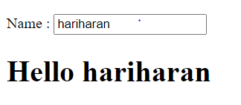

**EX NO :2 ANGULAR-2**

**10/09/20**

**Script5-1.js:**

var myApp = angular.module("myModule", []);

myApp.controller("myController", function($scope) {

$scope.message = "Welcome to AngularJS";

});

**Ang5.html:**

<!DOCTYPE html>

<html ng-app="myModule">

<script

src="https://ajax.googleapis.com/ajax/libs/angularjs/1.6.9/angular.min.js"></script>

<script src="C:\Users\HP\Documents\awt\script5-1.js"></script>

<body>

<div ng-controller="myController">

Hello!<br />

{{message}}

</div>

</body>

</html>

**OUTPUT:**



**EX NO :3 ANGULAR-3**

**10/09/20**

**Script5-3.js:**

var app = angular.module("myApp", []);

app.controller("myCtrl", function($scope) {

$scope.firstName = "Hariharan";

$scope.lastName = "Santhnam";

$scope.message = "Iam Welcoming All of u!!";

});

**Ang5-3.html:**

<!DOCTYPE html>

<html ng-app="myApp">

<script src="https://ajax.googleapis.com/ajax/libs/angularjs/1.6.9/angular.min.js"></script>

<script src="C:\Users\HP\Documents\awt\script5-3.js"></script>

<body>

<div ng-controller="myCtrl">

Hello!<br />

{{ firstName}}&nbsp;&nbsp;&nbsp;{{lastName }}<br />

{{message}}

</div>

</body>

</html>

**OUTPUT:**

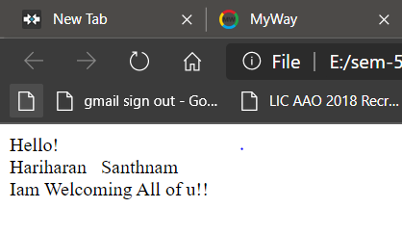

**EX NO :4 ANGULAR-4**

**10/09/20**

**Scrip5-5.js:**

var myApp = angular.module("myModule", []);

myApp.controller("myController", function($scope) {

var emp = [

{name: "Sam", age: "28", salary: "80000"},

{name: "David", age: "30", salary: "120000"},

{name: "Ram", age: "25", salary: "90000"}

];

$scope.employee = emp;

});

**Ang5-5.html:**

<!DOCTYPE html>

<html ng-app="myModule">

<script src="https://ajax.googleapis.com/ajax/libs/angularjs/1.6.9/angular.min.js"></script>

<script src="C:\Users\HP\Documents\awt\script5-5.js"></script>

<body>

<div ng-controller="myController">

<table>

<thead>

<tr>

<th>Name</th><th>Age</th><th>Salary</th>

</tr>

</thead>

<tbody>

<tr ng-repeat="e in employee">

<td>{{e.name}}</td>

<td>{{e.age}}</td>

<td>{{e.salary}}</td>

</tr>

</tbody> </table>

</div></body></html>

**OUTPUT:**

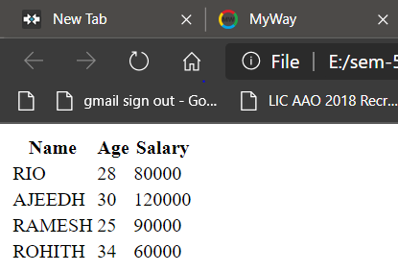

**EX NO :5 ANGULAR-5**

**10/09/20**

<!DOCTYPE html >

<html ng-app="myModule">

<head>

<script src="https://ajax.googleapis.com/ajax/libs/angularjs/1.6.9/angular.min.js"></script>

<script>

var myApp = angular.module("myModule", []);

myApp.controller("myProductDetailCtrl", function($scope) {

$scope.isHidden = true;

// a function, placed into the scope, which can toggle the value of the isHidden variable

$scope.showHideColors = function () {

$scope.isHidden = !$scope.isHidden;

}

});

</script>

<style>

body {

font-family: "Lucida Grande", "Lucida Sans Unicode", Helvetica, Arial, sans-serif;

}

div { margin: 20px; padding: 20px; font-size: 16px; color:#ffffff; }

#red { background-color: red; }

#green { background-color: green; }

#blue { background-color: blue; }

#purple { background-color: purple; }

#gray { background-color: gray; }

#olive { background-color: olive; }

</style>

</head>

<body ng-controller="myProductDetailCtrl">

<h2>AngularJS Socks</h2>

<p>Keep warm this winter with our 100% wool, 100% cool, AngularJS socks!</p>

<button ng-click="showHideColors()" type="button">

{{isHidden ? 'Show Available Colors' : 'Hide Available Colors'}}

</button>

<div id="red" ng-hide="isHidden">Red</div>

<div id="green" ng-hide="isHidden">Green</div>

<div id="blue" ng-hide="isHidden">Blue</div>

<div id="purple" ng-hide="isHidden">Purple</div>

<div id="gray" ng-hide="isHidden">Dark Slate Gray</div>

<div id="olive" ng-hide="isHidden">Olive</div>

</body>

</html>

**OUTPUT:**

